**Senior Software Report 6**

Team 1 – TUtor Me

Bonnie Brent, Danny Saltus, James Seales, William Shepherd, Kenny Wong

Final System Requirements and Documentation

# Problem Description

TutorMe aims to solve the problems for Trinity students in the following areas:

**Peer Tutors:** Many students as well as academic departments put a lot of time and effort in providing students with the option of tutoring sessions. The problem, is that often these sessions or individual tutors are very rarely advertised. There is little to no information on the Trinity website regarding how to get in contact with peer tutors. Most of the time, students must rely on ads that are posted on the walls or bulletin boards around campus.

**Study Events**: Students often wish to have study sessions before big exams and midterms in their classes. If the student doesn’t know anybody in their class, they may be not able to have the benefit of a study group. With TutorMe students can find study sessions that are designed for their specific classes without needing to be friends with their classmates outside of their class or on social networking sites like Facebook or Google Plus. This model ensures the possibility for the highest attendance and therefore most effective study session.

**Academic Calendar:** Viewing the Academic Calendar on your mobile device from the Trinity website is not the most user-friendly experience. Its large PDF format forces the user to pinch, zoom, and manipulate the document in many ways. In TutorMe the calendar is formatted in an easy to read tableview that requires no manipulation by the user.

**Honor Code:** The Honor Code portion of our application provides an overview of the Honor Code at Trinity University. This is designed to make students aware of the Honor Code history as well as provide answers to frequently asked questions to new students who many not be familiar with the Honor Code. Like the academic

# 

# Updated System Specifications and Requirements

**Tutor**

* Prompt user to create tutor profile
* Display list of tutors
  + Filter by subject
* Search for specific tutor
  + By name
  + By subject
  + By class rank
  + By email
* View tutor profile
  + Subjects Tutored
  + Contact information
  + Description
  + General Times Available
  + Actions: Call Tutor, Email Tutor

**Study Events**

* Prompt user to create study session
* Display list of study sessions and organizer
  + Filter by subject, date/time
* Search for specific study session
  + By name of organizer
  + By Class
* View study session detail
  + When/where
  + Contact Information
  + Description
  + RSVP/number of students
  + Actions: Call Organizer, Email Organizer
* Set reminders

**Academic Information**

* View academic calendar
  + Fall 2011
  + Spring 2012
* Honor Code
  + The Code
  + Philosophy and Background
  + FAQ

**Settings**

* Tutor Profile
  + Enable Profile (your tutor profile shows in tutor feed)
  + Edit Profile
* Events
  + Organized Events (Shows events for which you are the organizer)
  + Events Attending (Shows events for which you have RSVP’d)
* Account
  + Notifications
  + About (Application Info for TutorMe)

**\*\*Handling of inappropriate content**

We have decided not to worry about a rating system for the tutors. We hope to construct some sort of filter in the web service that will search for certain words/phrases in tentative postings. If the filter finds a word or phrase that is deemed to be not allowed, the post will not make it through the process, and will not be posted on the app. Might add the functionality of sending email to user saying that there post was denied. Also users will have the ability to flag inappropriate content that might have made it through our filter. After 5 flags your post will automatically be removed from the application.

# Brief Statement on Satisfying Requirements

Filtering

* We are still considering many options regarding filtering. These include a section for recently added tutors and events. Also the option to view events that are happening this week and other time/date options.

Group Tutor/Event (not listed above)

* We are still considering the best way to implement a group of tutors/ regularly scheduled tutoring events (i.e. ACM tutoring for computer science students)

Study Event Reminders

* We have yet to implement the option of setting reminders for the study events a user RSVP’s to

Account Notifications

Handling of Inappropriate Content

* Contemplating the decision to have a flagging system as described above, in which five flags would have your posting removed

We also hope to add the functionality of exporting study event information as well as academic calendar information to the devices native calendar application to benefit the user.

# Documentation – User Manual / Instructions

## Tutor Tab

This is the first tab/view of our application and is also the main feature of our app. Here the user is presented with a list of categories to choose from to help them filter the type of tutors that they see. One they select a category there are presented with a searchable list of individual tutors with quick look at the tutor’s major, name, and class rank. The user simply selects an individual tutor to view more detailed information such as contact info, general times available, and other important information.

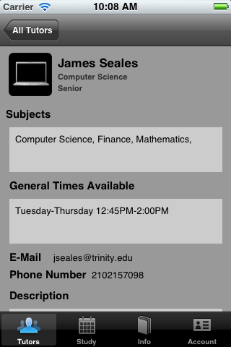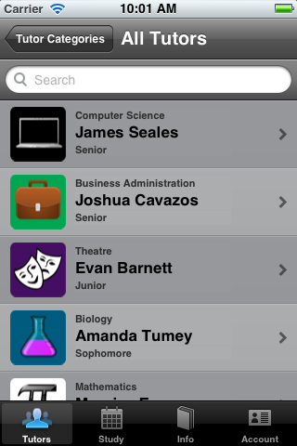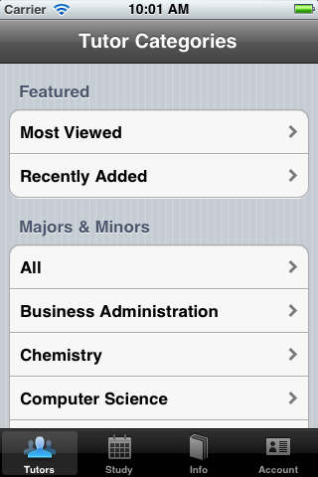

## Study Tab

This is the second tab/view of our application. Here the user is presented with a list of categories to choose from to help them filter the type of study events that they see. One they select a category there are presented with a searchable list of study events with quick look at the class name, class number, and event organizer name. The user simply selects an individual tutor to view more detailed information such as event description, date and time, location, contact information for the organizer, and RSVP information.

## 

## 

## Academic Information Tab

This is the third tab/view of our application. Here the user is presented two sections: Academic Calendar and Honor Code.. The user simply selects the semester they want to see the academic calendar for that term. In the Honor Code section, the user selects the one of the three information categories that they want to view.

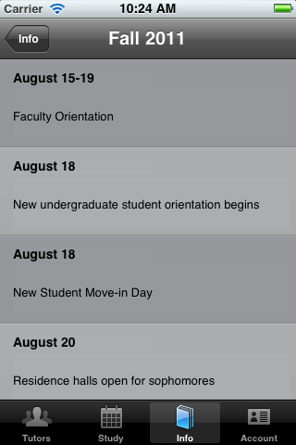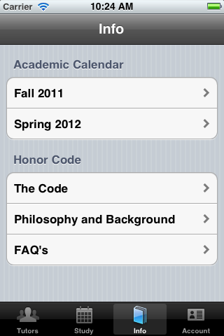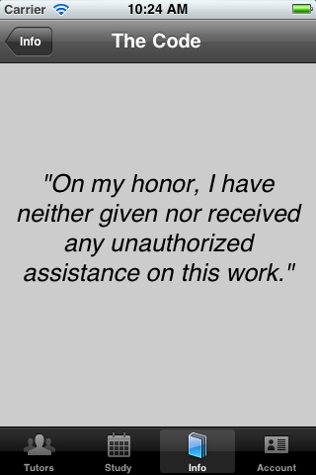

## Account Tab

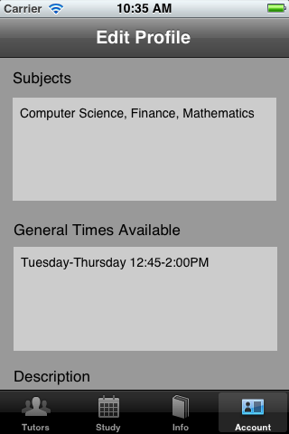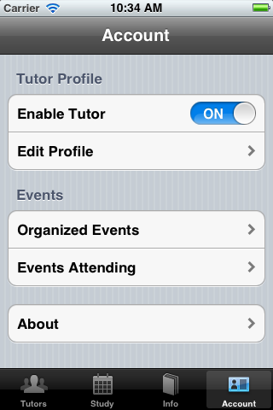This is the fourth and final tab/view of our application. Here the user is presented three sections: Tutor Profile, Events, and Settings. Enable Tutor is a toggle switch that will add the users tutor profile as active when enabled, and will disable their profile from viewing when disabled. Here the edit profile section allows the user to change their tutor information such as contact info, general times available and more. In the events section, the user is able to view the events they are the organizer of as well as the events they are attending. This allows the user a quick view instead of having to search for these events in the study events tab. The about section contains information regarding our application such as the members of the team as well as a link to compose an email if the user has any comments or questions regarding the application.



 